All the Mathematical operation are known as Expressions

such as:

1+2+3 = 6

2 * 3 = 6

20 / 4 = 5

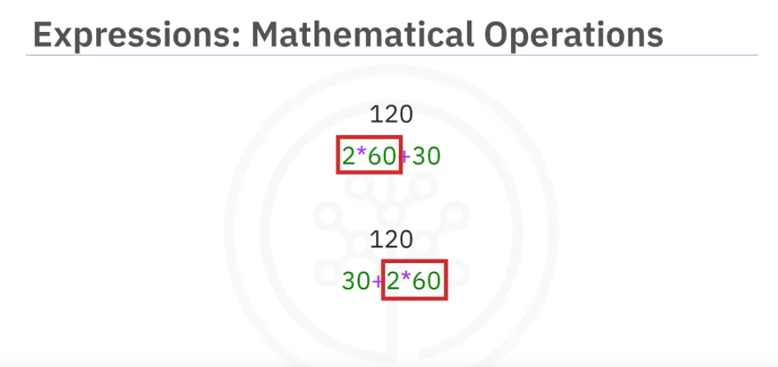

Now in above pic you can see that in above pic both expression have same value/operands and operators BUT different order, So remember that **python** will always first solve multiplication and then do addition irrespective of order. Bcuz python follows the Bodmas rules. Therefore if **bracket** come in expression so it will give the first priority to it and then So on…



First solve bracket